Flow Name: Client Change Requests – Smartsheet to Slack & Completion Notification
Problem:
Client change requests are managed in Smartsheet by CSMs, but without automation there is no reliable way to notify the accounting team in real time or confirm when a request has been completed. This results in delayed actions, unclear ownership, and repeated manual follow-ups between teams.
Solution:
This automation uses Smartsheet as the system of record for client change requests and Slack as the communication layer. It automatically notifies the accounting team when a new request is raised and posts a threaded completion message when the request is marked as done.
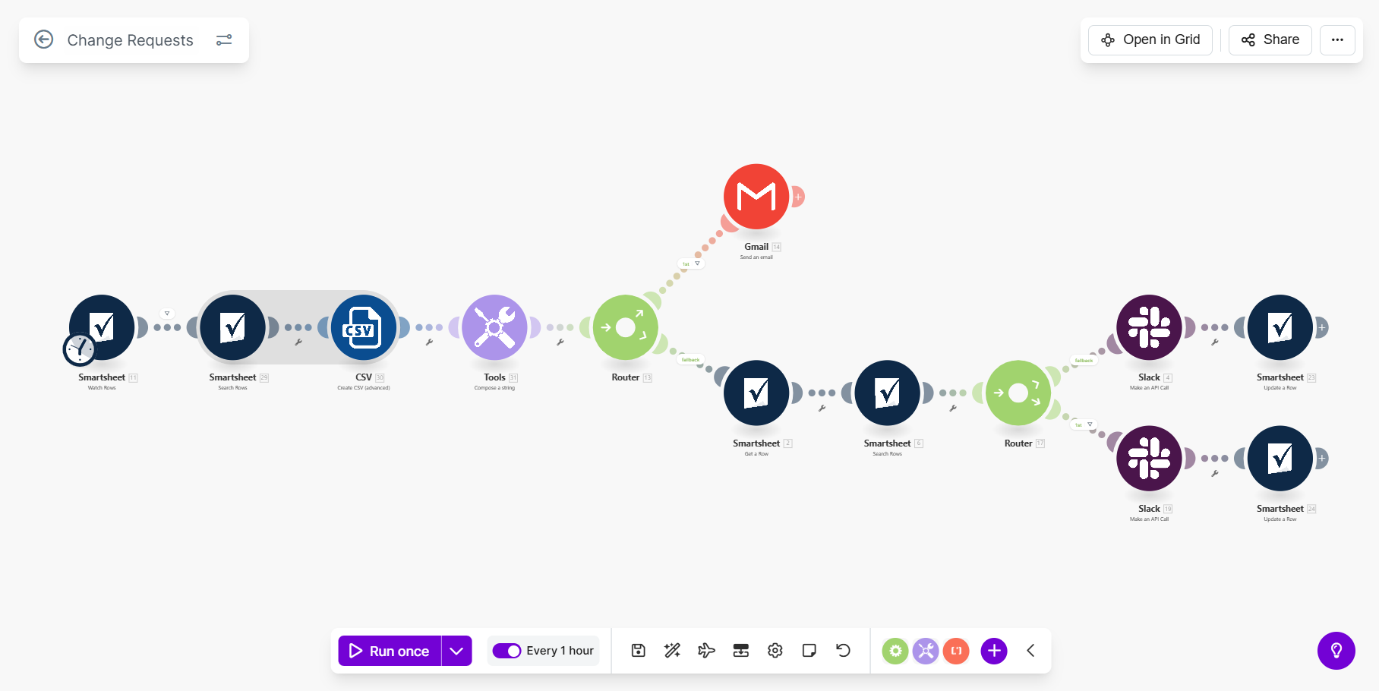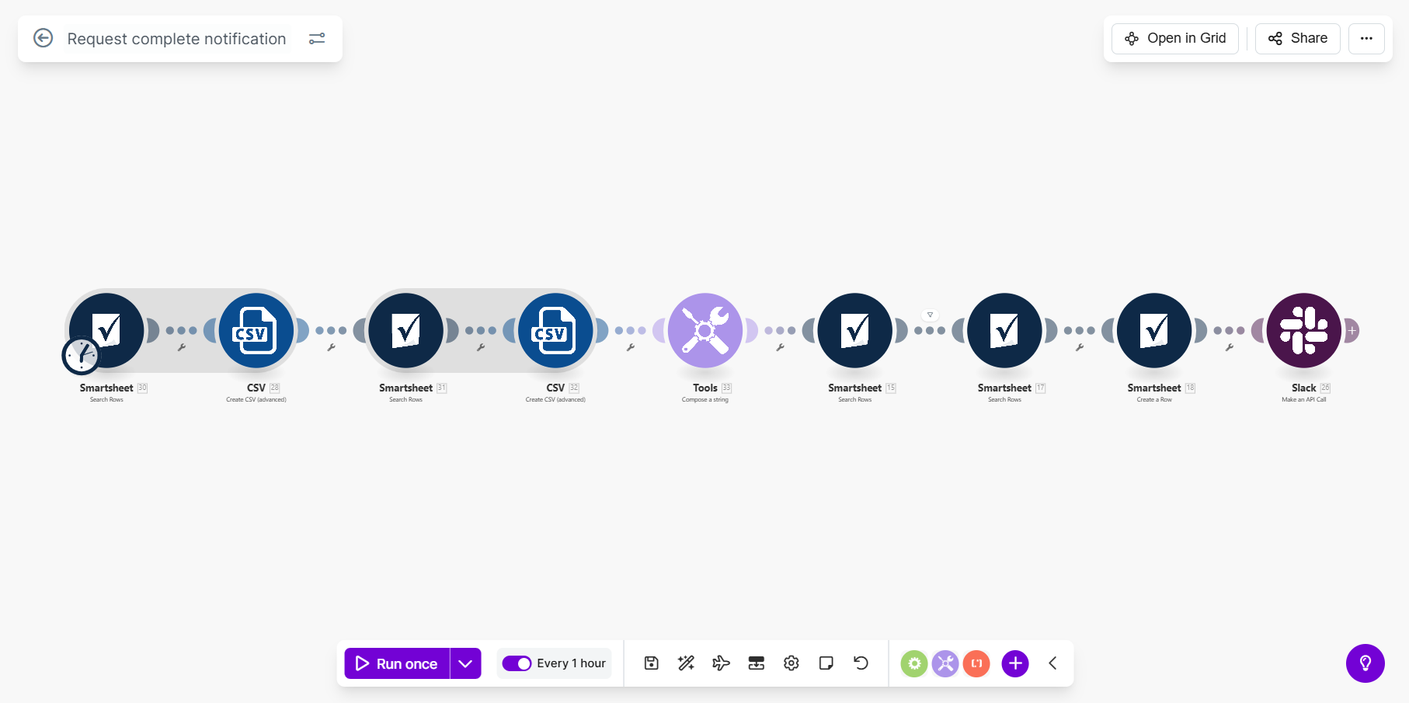

Flow Details:
Step 1: Trigger – Monitor Change Requests Sheet
The automation continuously monitors the CB Change Requests Smartsheet using the Watch Rows module. Each row represents a client-initiated change request submitted by a CSM. The flow captures the full row data whenever a new request is added or updated.
Step 2: Validate Required Request Fields
The flow validates that all mandatory fields are populated, including Client Name, Request Type, Requestor Name, and reference Link. If any required value is missing, the automation stops and sends a failure notification email to the internal team requesting data correction.
Step 3: Load CSM Mapping Configuration
The automation retrieves the CSM Mappings Smartsheet, which contains mappings between CSM names, Slack user IDs, target Slack channels, and reference links. This configuration enables dynamic routing without hardcoded values.
Step 4: Normalize and Aggregate CSM Data
The retrieved CSM mapping data is normalized and aggregated into a searchable text structure. This allows efficient matching between the requestor name in the change request and the corresponding Slack metadata.
Step 5: Route Request for Slack Notification
A router evaluates whether the request is valid, non-duplicate, and properly mapped to a Slack destination. Only requests that meet all criteria proceed to notification.
Step 6: Post Change Request Message to Slack
For valid requests, the automation posts a structured Slack message in the mapped accounting channel. The message includes the client name, request type, comments, responsible CSM, and a direct link to the Smartsheet request. This message acts as the parent message for all future thread updates.
Step 7: Monitor Request Completion Status
The automation continues monitoring the CB Change Requests sheet for rows marked as completed, such as when audit or “done” indicators are updated by the accounting team.
Step 8: Match Completed Request to Original Slack Message
Once a request is marked complete, the automation identifies the original Slack message associated with that request using stored references and mappings to ensure updates are posted in the correct thread.
Step 9: Post Completion Notification in Slack Thread
A threaded Slack message is posted under the original request message confirming that the client change request has been completed. This notification provides clear visibility to the CSM and stakeholders that the request has been closed.

